VIDEO 5 • ILLUSTRATED STUDY NOTES

Structured Output in LangChain
Turn open-ended model text into typed, validated objects suitable for APIs, databases and automation.
Length: 1:08:13 · Watch lesson · Course playlist

What you should learn
- Unstructured prose is hard for software to consume reliably.
- with_structured_output lets supported chat models target a schema.
- TypedDict provides structural type hints; Pydantic performs runtime validation.
- JSON schema is flexible but must be combined with validation and error handling.

Video chapter bookmarks
EVERY TIME OPENS THE EXACT CHAPTER ON YOUTUBE
00:00 | Intro
01:13 | Recap
02:09 | What is Structured Output?
05:17 | Why do we need structured output?
11:40 | Ways to get structured output
14:08 | with_structured_output function
15:33 | TypedDict
36:07 | Pydantic
01:02:32 | JSON
01:02:58 | When to use?
01:04:53 | Important Points
01:07:47 | Outro

Detailed learning notes

1. What does “structured output” mean?
▶ Watch at 02:09
Unstructured model output is ordinary prose: “The customer is upset and needs a refund.” Structured output follows a machine-readable shape such as `{"sentiment":"negative","intent":"refund"}`.
A schema specifies expected field names, types and sometimes allowed values. This is how you turn an LLM into a component that other software can consume—while retaining normal validation and error handling.
- Unstructured: free-form natural-language paragraph.
- Structured: predictable field names and data types.
- Schema compliance is necessary for automation, but it does not prove semantic correctness.
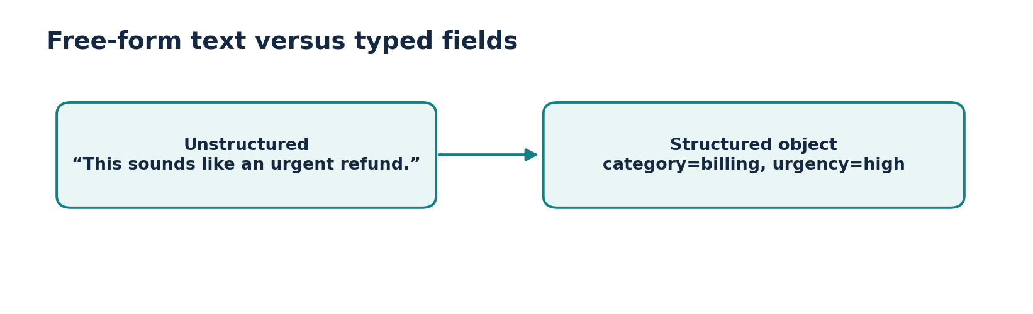
Figure • Unstructured versus structured output

2. Why software systems need a schema
▶ Watch at 05:17
APIs and databases cannot safely depend on text like “probably medium priority.” They require a stable contract: perhaps `priority` must be one of `low`, `medium`, `high`, and `confidence` must be a number.
Schema-first design makes downstream filters, dashboards and validators possible. A business rule can reject an unsupported category before sending a record to a database or triggering an action.
- Customer support ticket classification.
- Resume or invoice field extraction.
- Product categorization and routing.
- Function/tool arguments returned by an LLM.

3. Three practical approaches
▶ Watch at 11:40
You can ask for JSON in the prompt, use a compatible model’s native structured output or tool calling, or parse generated text after the call. These vary in reliability and in how much validation they provide.
Use provider-native structured output with an explicit schema when supported, then validate the result in Python. A “reply with JSON” instruction alone may produce code fences, missing fields or inconsistent types.
- Prompt-only JSON: easy but brittle.
- Schema-bound generation: provider capability dependent, usually more reliable.
- Post-processing: parse and validate; be prepared to retry or fail safely.

4. Understanding with_structured_output
▶ Watch at 14:08
A supported LangChain chat model exposes `.with_structured_output(schema)`, which returns a model wrapper targeting the requested response shape. Under the hood, providers may use JSON-schema constrained output or tool calling.
The returned type depends on the schema and integration. A Pydantic schema commonly returns a validated Pydantic object, while dictionary/JSON-schema targets often return dictionaries. Check your selected provider’s documented behavior and supported methods.
- Define the data contract before prompting.
- Use descriptions to reduce ambiguity.
- Catch parsing and validation failures instead of trusting every response.
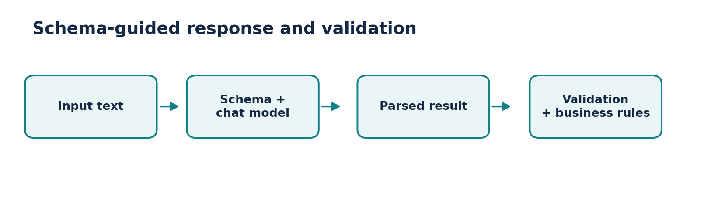
Figure • Schema-bound generation

5. TypedDict: a lightweight field specification
▶ Watch at 15:33
`TypedDict` specifies which keys and types are expected in a dictionary and is particularly useful for static type checking and concise schemas. It does not automatically validate arbitrary Python dictionaries at runtime.
When passed to an integration that supports schema-based output, its type annotations help build a requested schema. If strict runtime checks matter, validate the result separately or use Pydantic.
- Good for quick dict-shaped responses and simple contracts.
- `NotRequired` can express optional fields in supported schemas.
- Do not mistake Python typing annotations for runtime enforcement.
PRACTICAL CODE
from typing import TypedDict, Literal
class Ticket(TypedDict):
category: Literal["billing", "technical", "other"]
urgency: Literal["low", "medium", "high"]
summary: str
# With a compatible model:
# typed_model = model.with_structured_output(Ticket)
# result = typed_model.invoke("I was charged twice.")
# print(result["category"])

6. Pydantic: enforce data rules
▶ Watch at 36:07
Pydantic defines fields using `BaseModel` and validates data at runtime. `Field` descriptions and constraints can document intent, and `ValidationError` explains what failed. It is a strong choice when model output feeds databases, APIs or other sensitive workflows.
An important nuance: Pydantic validation confirms structure and constraints, not whether the LLM extracted the right facts. You still need domain checks, source verification and safe failure behavior.
- Set required types and restricted categories.
- Apply constraints (for example, score between 0 and 1).
- Catch errors and decide whether to ask for clarification, retry or reject.
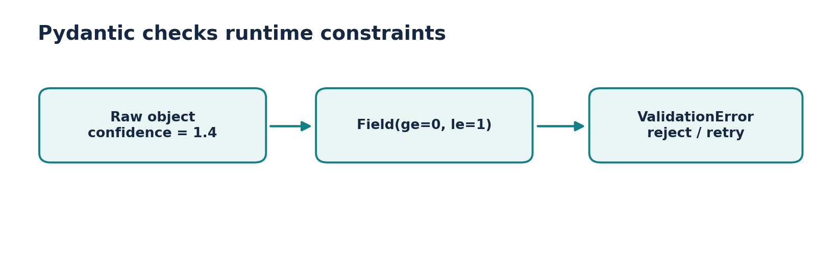
Figure • Runtime validation
PRACTICAL CODE
from pydantic import BaseModel, Field, ValidationError
from typing import Literal
class Ticket(BaseModel):
category: Literal["billing", "technical", "other"]
urgency: Literal["low", "medium", "high"]
confidence: float = Field(ge=0, le=1)
summary: str
raw = {"category": "billing", "urgency": "high",
"confidence": 0.93, "summary": "Duplicate payment"}
try:
result = Ticket.model_validate(raw)
print(result.model_dump())
except ValidationError as exc:
print(exc.errors())

7. JSON Schema: portable structure
▶ Watch at 01:02:32
JSON Schema is a language-independent way of describing JSON objects, arrays and constraints. It is useful when a Python application must exchange schema contracts with TypeScript, Java or an HTTP API.
A schema can declare `type`, `properties`, `required`, enums and additional-property behavior. Correctly generated JSON is only the first step: parse it and validate it before trusting it.
- Useful when schemas are shared across programming languages.
- Can be more verbose than a Python Pydantic model.
- JSON is a data format; a schema describes which JSON values are allowed.
PRACTICAL CODE
ticket_schema = {
"title": "Ticket",
"type": "object",
"properties": {
"category": {"type": "string", "enum": ["billing", "technical", "other"]},
"summary": {"type": "string"}
},
"required": ["category", "summary"],
"additionalProperties": False
}
# structured = model.with_structured_output(ticket_schema)

8. When to use which schema
▶ Watch at 01:02:58
Choose TypedDict for light, Python-centric dictionary contracts when you will manage validation independently. Choose Pydantic when runtime type and value checks are useful. Choose JSON Schema for cross-language interoperability or for matching an external API schema.
If the model lacks the structured-output capability you expect, test alternatives such as a parser plus retry, or switch model/integration. Capability and strictness may differ by provider.
- TypedDict → simple type hints.
- Pydantic → Python validation and developer ergonomics.
- JSON Schema → portable contract that interoperates across systems.
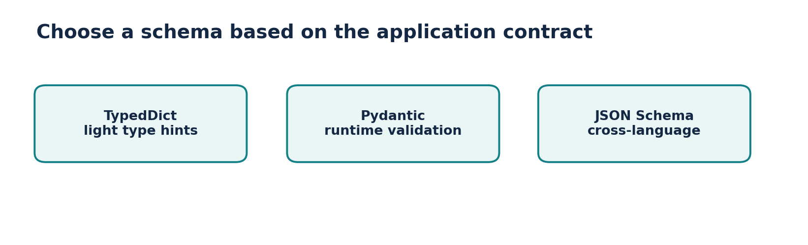
Figure • Schema options

9. Important production checks
▶ Watch at 01:04:53
Structured does not mean safe, truthful or complete. A model can return valid JSON with a fabricated amount, a wrong person, or a misleading confidence score. Store source evidence and route high-stakes actions through explicit confirmation.
Protect against missing fields, refusal responses, unexpected data, model-version changes, invalid enum values and partial results. Log safely and build a fallback route instead of trying to silently coerce every output.
- Validate schema + business constraints + evidence.
- Test adversarial and ambiguous inputs.
- Avoid executing actions solely on a generated field without appropriate checks.
- Use human review before irreversible changes.

Mini-project: customer-support ticket classifier
- Input: “I paid for my order twice and need the extra charge refunded.” Output: a typed object with `category`, `urgency`, `summary` and optional `confidence`.
- Write at least 10 test tickets, including mixed topics and unclear requests. Check both schema validity and classification accuracy.
- Route billing tickets to a separate queue—but only after business rules authorize the requested action.
Reference implementation / practice scaffold
# Complete offline contract demonstration (does not call an LLM).
from pydantic import BaseModel, Field
from typing import Literal
class Triage(BaseModel):
category: Literal["billing", "technical", "other"]
urgency: Literal["low", "medium", "high"]
summary: str = Field(min_length=5, max_length=200)
candidate = {"category": "billing", "urgency": "high",
"summary": "Customer reports duplicate payment"}
validated = Triage.model_validate(candidate)
assert validated.category == "billing"
print(validated.model_dump_json(indent=2))

Common mistakes to avoid
- TypedDict annotations alone do not validate arbitrary dictionaries.
- Valid JSON can contain factually incorrect extracted values.
- Provider support for strict output varies: check capabilities before relying on them.

Quick revision / self-test
1. What is the difference between JSON and JSON Schema?
2. Why is Pydantic useful even when the model already returns a dictionary?
3. How would you handle invalid output in a payment-related workflow?
4. Can a schema guarantee that an extracted number is true? Why not?

Related documentation
LangChain Python documentation
LangChain Core API reference
CampusX course playlist

